David Willis

Lingma Acheson

CIT 304

2.2.18

Course Project 2

Query 1 – Query to show current date and time with a specific format (day (00), month (first three letters), and year (four digits))

ALTER SESSION SET NLS_DATE_FORMAT = 'DD-MON-YYYY HH24:MI:SS';

SELECT CURRENT_DATE FROM DUAL;

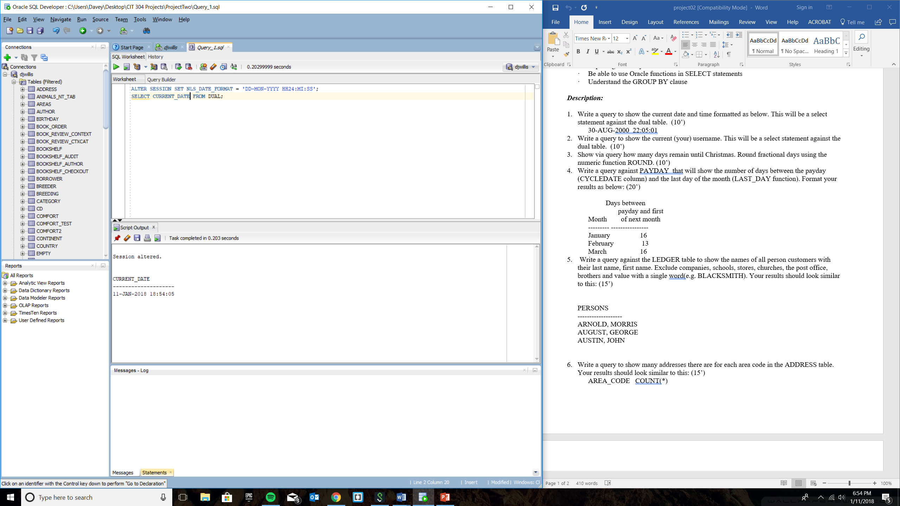

Query 2 – Show current username whom is utilizing database

select user from dual;

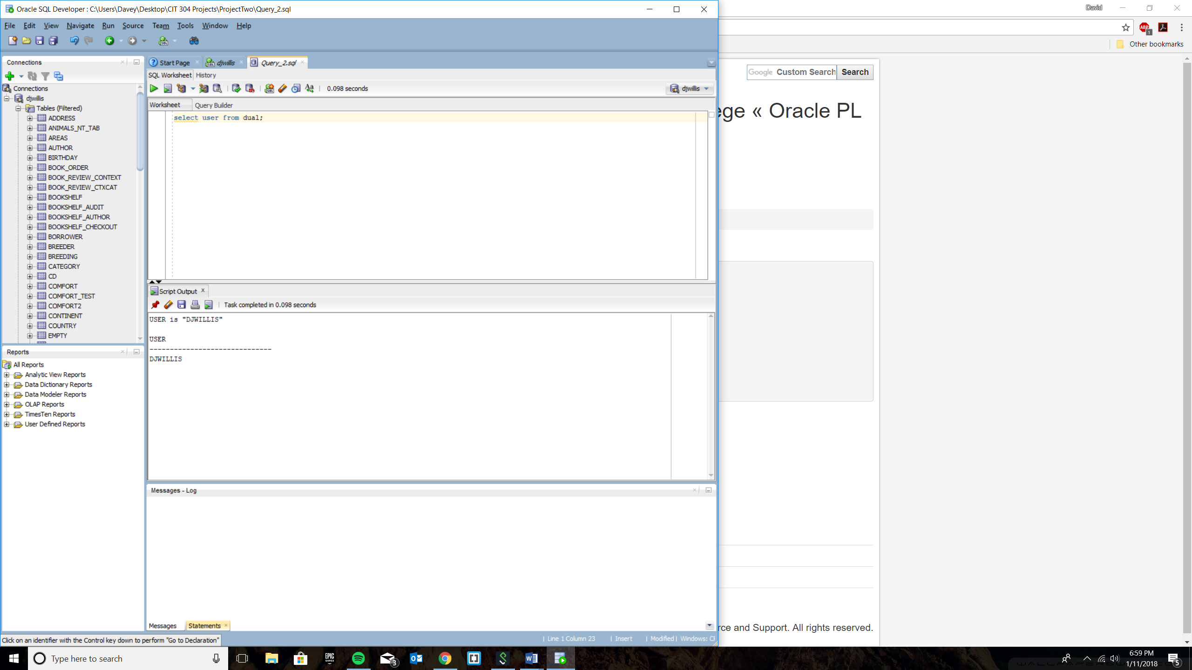

Query 3 – Count how many days left until Christmas of 2018

SELECT ROUND(date '2018-12-25' - CURRENT_DATE) as dateDiff

from dual;

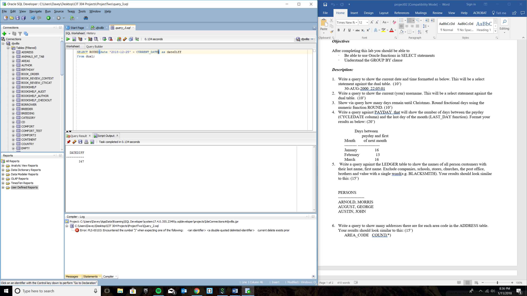

Query 4 – Shows number of days between payday and the last day of that payday month

SELECT to_char(CYCLEDATE, 'Month') "Month", (LAST_DAY(CYCLEDATE) - CYCLEDATE) "Days between"

FROM PAYDAY;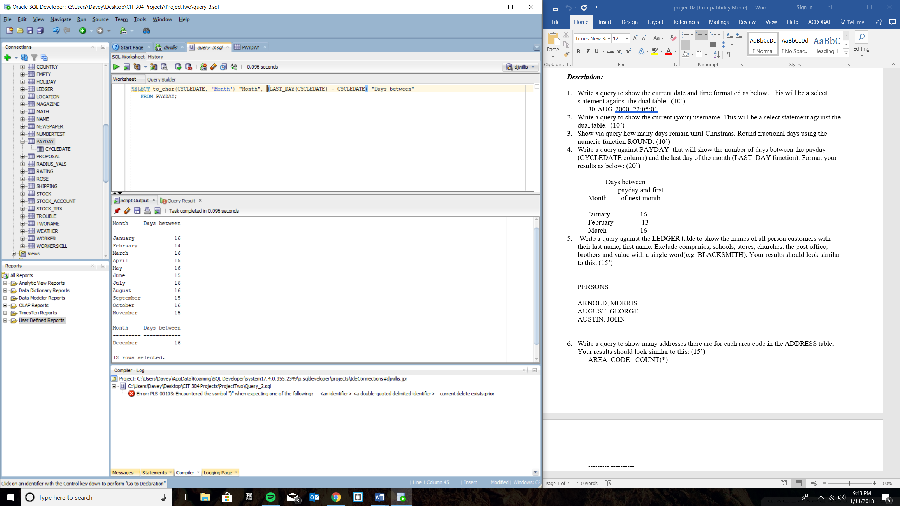

Query 5 – Show only real persons’ names rather than organizations and brothers from LEDGER table

SELECT PERSON FROM LEDGER WHERE NOT (PERSON LIKE '%STORE'

OR PERSON LIKE '%OFFICE'

OR PERSON LIKE '%CHURCH'

OR PERSON LIKE '%HARDWARE'

OR PERSON LIKE '%AND%'

OR PERSON LIKE 'BLACKSMITH'

OR PERSON LIKE 'SCHOOL'

OR PERSON LIKE 'LIVERY'

OR PERSON LIKE '%COMPANY'

OR PERSON LIKE 'MILL');

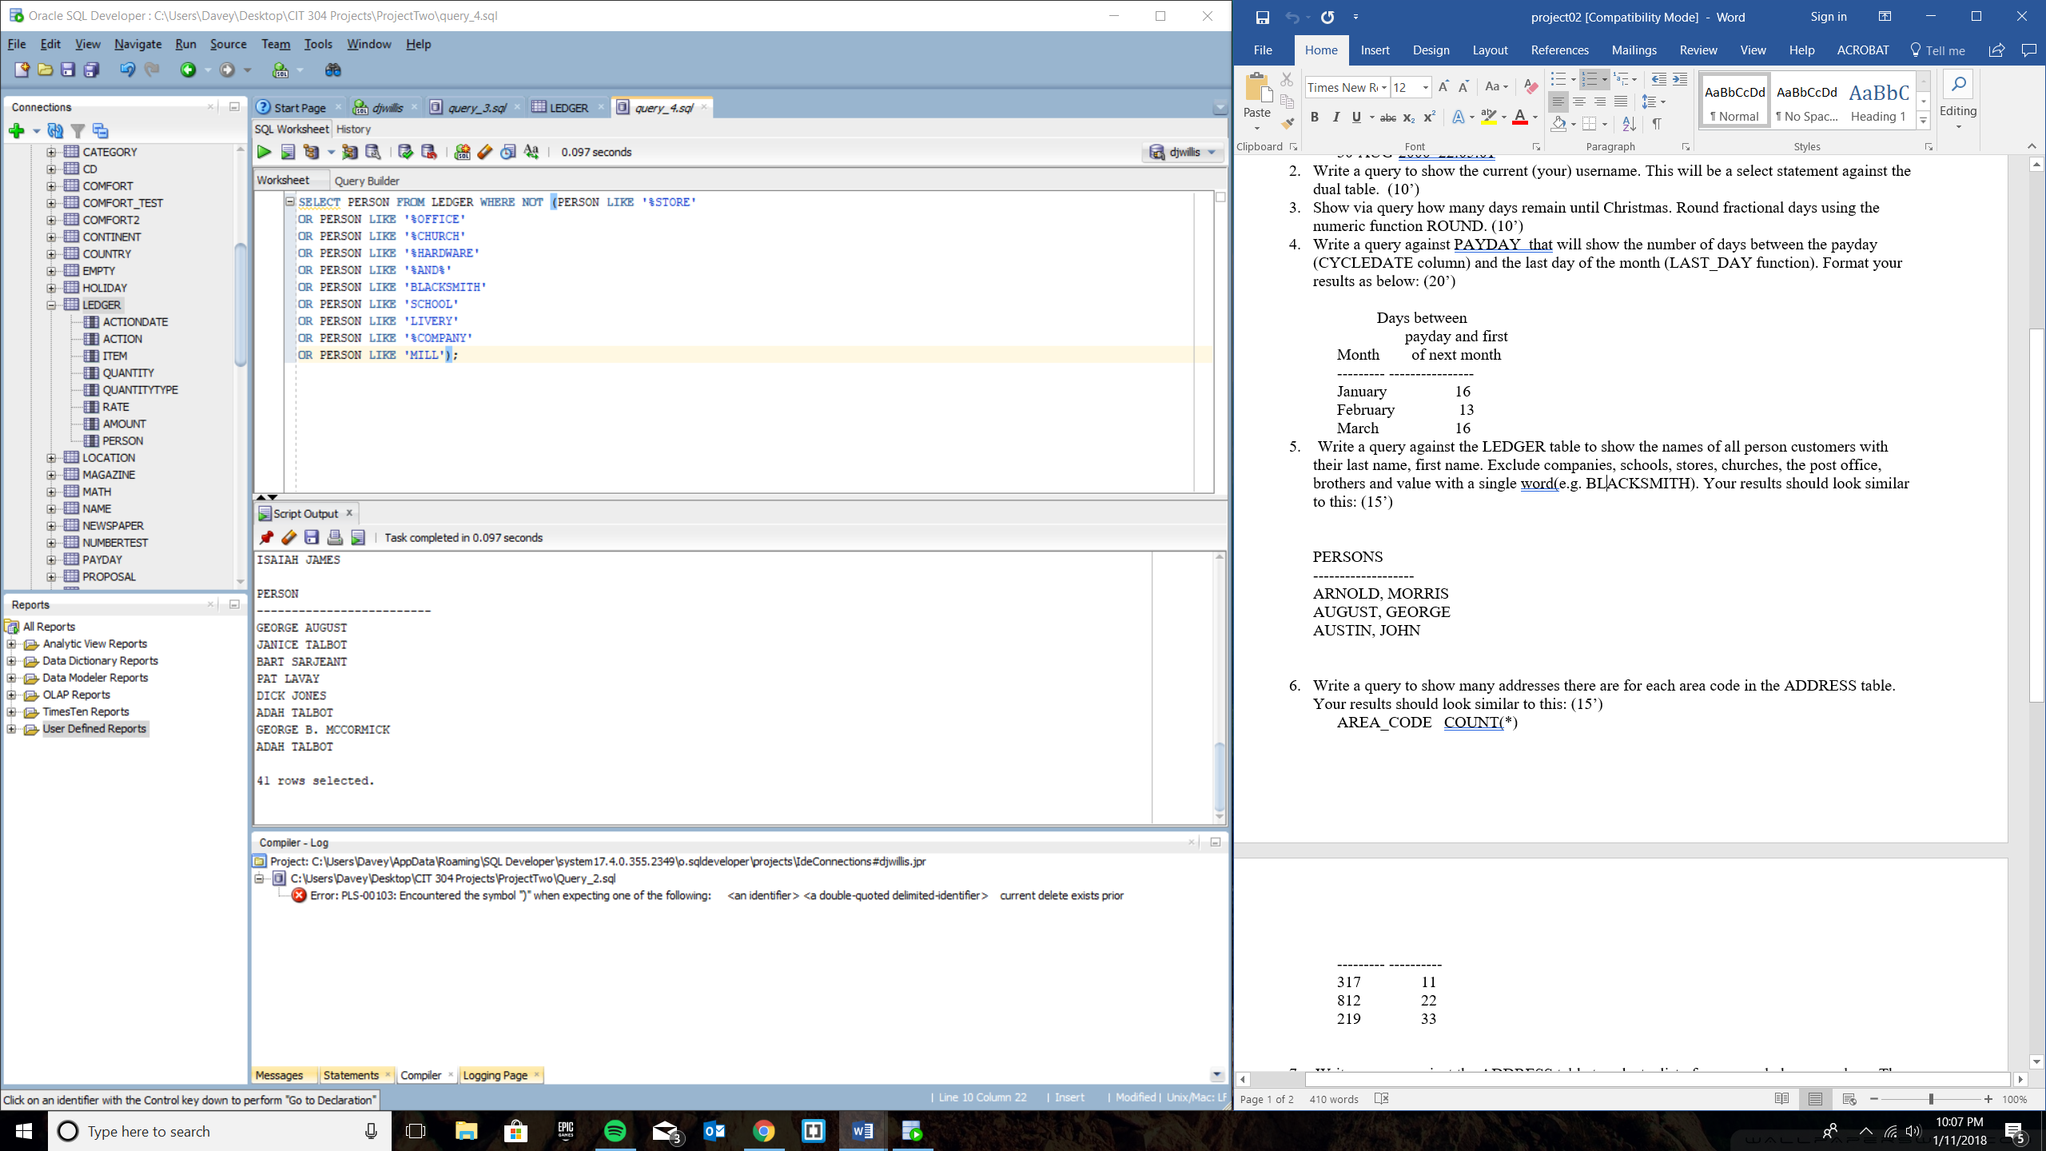

Query 6 – Print out a list of shared area codes from the list of phone numbers and list how many times they are repeated across the list

SELECT SUBSTR(PHONE,1,3) "AREA_CODE", COUNT(SUBSTR(PHONE,1,3)) "COUNT(*)" FROM ADDRESS GROUP BY SUBSTR(PHONE,1,3) HAVING COUNT(SUBSTR(PHONE,1,3))>1;

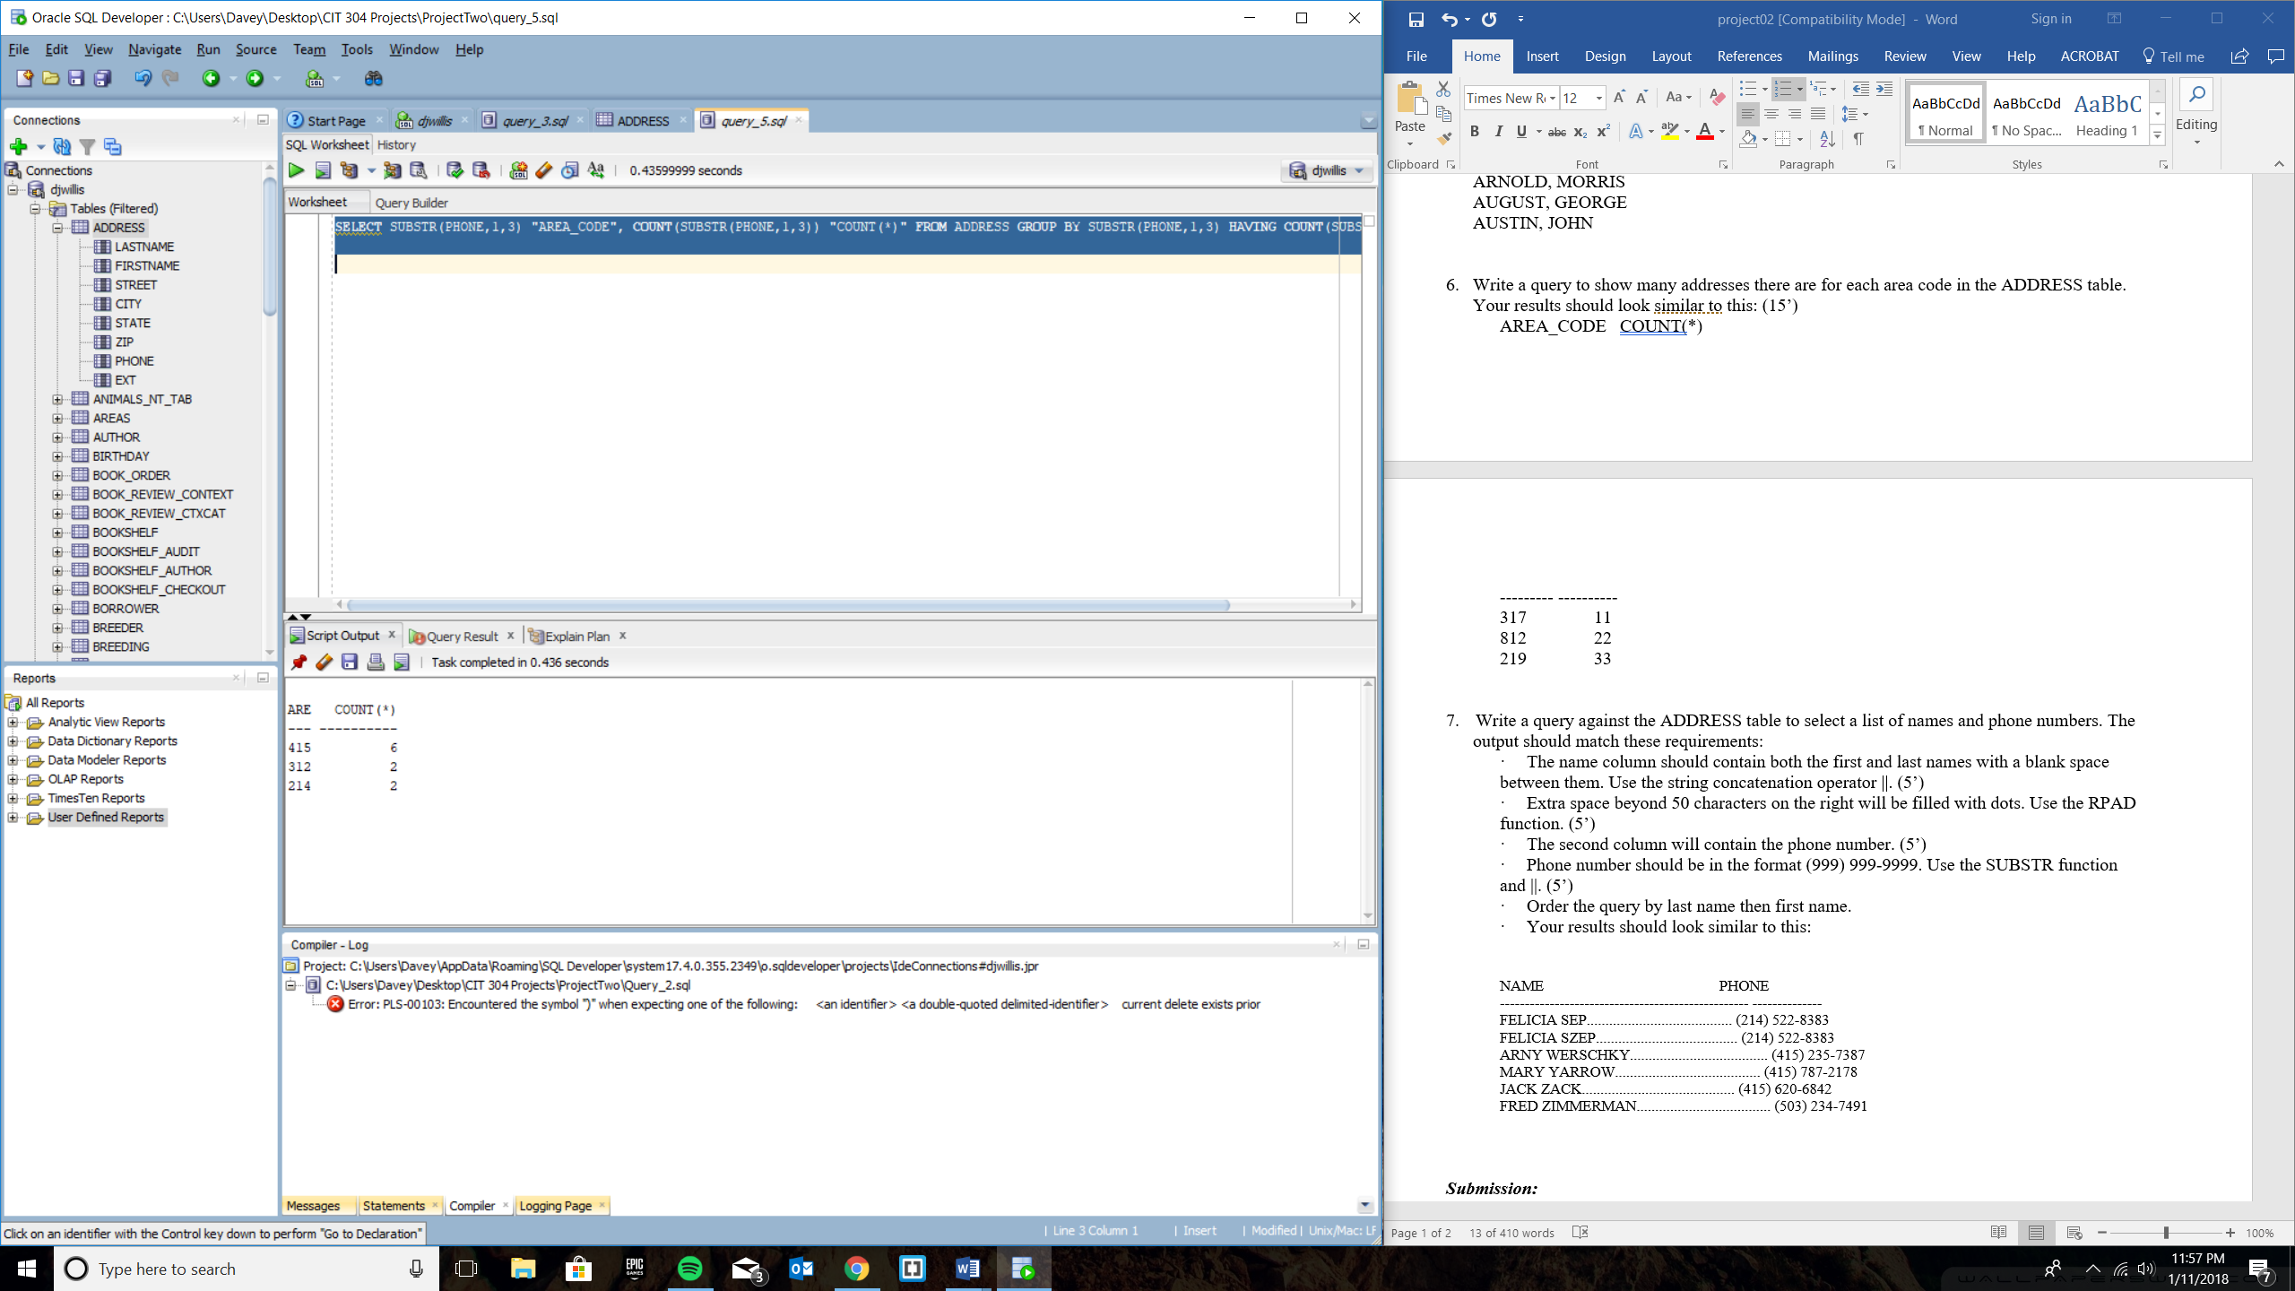

Query 7 – Concatenate first name and last name columns from ADDRESS table and also add their corresponding phone numbers formatting like (777) 777-7777 and also ordering the rows by last name ascending and then first name ascending.

SELECT RPAD(FIRSTNAME || ' ' || LASTNAME,50,'.') As FullName,

'(' || SUBSTR(PHONE,1,3) || ')' || SUBSTR(PHONE,5,12) As Phone

FROM ADDRESS

ORDER BY LASTNAME ASC, FIRSTNAME ASC;

